**A Project Report on**

Driver Drowsiness Detection System with OpenCV & Keras

*Submitted in the Partial Fulfillment of the Requirements for the award of*

**Bachelor of Technology in**

**Electronics & Communication Engineering**

*By*

**Chakshu Chaturvedi(20195104)**

**Darin Carvalho(20195097)**

Under the guidance of

**Asim Mukherjee (Associate Professor)**



**Department of Electronics & Communication Engineering Motilal Nehru National Institute of Technology Allahabad Allahabad – INDIA**

**Department of Electronics and Communication Engineering Motilal Nehru National Institute of Technology Allahabad Prayagraj- 211 004**

**(India)**



## UNDERTAKING

We declare that the work presented in the project is entitled ‘**Driver Drowsiness Detection System with OpenCV & Keras’ submitted** to the Department of **Electronics and Communication Engineering**, Motilal Nehru National Institute of Technology Allahabad (India) as a part of B.Tech. VIII Semester course curriculum is our original work. We neither have plagiarized any part of the present project nor submitted the same work for the award of any other degree elsewhere.

In case this undertaking is found incorrect, the B. Tech project work may be withdrawn unconditionally.

**(Chakshu Chaturvedi) (Darin Carvalho)**

Date: 1st May 2023

## ACKNOWLEDGEMENT

We would like to express our sincere gratitude to our guide and mentor, Assistant Professor **Asim Mukherjee** of Electronics and Communication Engineering Department, MNNIT for his continuous and unfailing support, guidance and help, which have been invaluable during the course of this project. His knowledge, insight and constant motivation at each step of the project has been instrumental in its completion. Our team faced several obstacles during the development of the project. Sir helped us get through this and clarify concepts and perspectives. Our team is happy to have a supervisor who clearly explains the concept of quality and is always available to answer our curious questions.

Date: 1st May 2023 Place: Prayagraj

Chakshu Chaturvedi

Darin Carvalho

**Department of Electronics & Communication Engineering**

**Motilal Nehru National Institute of Technology Allahabad Allahabad – INDIA**

## CERTIFICATE

This is to certify that the work contained in the thesis titled ‘Driver Drowsiness Detection System with OpenCV & Keras’

submitted by **Chakshu Chaturvedi and Daron Carvalho** in the partial fulfillment of the requirement for the award of Bachelor of Technology in Electronics and Communication Engineering to the Electronics and Communication Engineering Department, Motilal Nehru National Institute of Technology, Allahabad, is a bonafide work of the students carried out under my supervision.

Date: 1st May 2023 Place: Prayagraj

Asim Mukherjee Associate Professor

ECE Department MNNIT, Allahabad

## ABSTRACT

Drowsiness detection is a safety technology that can prevent accidents caused by drivers who fall asleep while driving. This paper presents a Python project that builds a drowsiness detection system using OpenCV, Keras and convolutional neural networks (CNN). The system captures images from a webcam and detects the face and eyes of the driver. The eyes are then fed into a CNN model that classifies them as open or closed. A score is calculated to measure the drowsiness level of the driver and an alarm is triggered when the score exceeds a threshold. The project describes the data collection, model building and testing processes, as well as the results and limitations of the system.

The project explores an implementation in Python and its libraries for image processing, computer vision and machine learning can be applied to develop a drowsiness detection system that can perform robustly and efficiently in real-world scenarios and reduce the risk of fatal accidents.

# TABLE OF CONTENT

Acknowledgement Page No. 3

Certificate Page No. 4

Abstract Page No. 5

### Chapter 1:- INTRODUCTION

* 1. General Page No. 7
  2. Objective Page No. 8

### Chapter 2:- LITERATURE REVIEW

* 1. Image Processing Page No. 9
  2. OpenCV Page No. 10
  3. OCR Page No. 11

### Chapter 3:- IMPLEMENTATION

* 1. Steps involved Page No. 13
  2. Code Page No. 14

### Chapter 4:- ANALYSIS

* 1. Results Page No. 16
  2. Uses Page No. 17

### Chapter 4:-

**Smart Number Plate Vs Normal Vehicle Number Plate** Page No. 18

Conclusion Page No. 21

Reference Page No. 22

Contribution Page No. 23

**CHAPTER 1**

**Introduction:**

* 1. General  
     1. Human beings have always created machines and methods to facilitate and safeguard their lives, for routine tasks like commuting to work, or for more adventurous ones like flying in airplanes. As technology progressed, so did the modes of transportation and our reliance on them. They have significantly influenced our lives as we know them. Now, we can travel to destinations at a speed that our ancestors could not have imagined. In contemporary times, almost everyone in this world utilizes some form of transportation every day. Some people are affluent enough to own their own vehicles while others depend on public transportation. However, there are some rules and standards for those who drive regardless of their economic status. One of them is being alert and attentive while driving. Ignoring our obligations towards safe travel has resulted in hundreds of thousands of casualties linked to this remarkable invention every year. It may appear like a minor issue to most people but adhering to rules and regulations on the road is crucial. On the road, a vehicle has the most power and in reckless hands, it can be harmful and sometimes, that negligence can endanger lives even of the people on the road. One type of negligence is not acknowledging when we are too exhausted to drive. To detect and prevent a disastrous outcome from such negligence, many researchers have conducted studies on driver drowsiness detection systems. This project explores an implementation of the same concept.
  2. **Objective**
     1. The objective of this project is to develop and evaluate a drowsiness detection system using Python, OpenCV and Keras that can alert drivers when they are feeling sleepy and prevent accidents. The system will use a webcam to capture images of the driver’s face and eyes and feed them into a convolutional neural network (CNN) model that will classify them as open or closed. The system will also calculate a score to measure the drowsiness level of the driver and trigger an alarm when the score exceeds a threshold. The project will use a self-collected dataset of around 7000 images of eyes under different lighting conditions to train and test the CNN model.

.

## CHAPTER 2 LITERATURE REVIEW

* 1. **Image Processing**

Image processing plays a crucial role in Drowsiness detection and recognition. The process involves several steps that aim to enhance the quality of the image, detect the face, segment the eyes, and finally recognize the status of the driver. The following are the image processing techniques used in Drowsiness Detection.

* + 1. Pre-processing: The pre-processing step involves enhancing the quality of the image by removing noise, correcting the contrast, and adjusting the brightness. This step aims to prepare the image for further processing by improving its quality and reducing any artifacts that may hinder Vehicle Number Plate detection.
    2. Edge detection: The edge detection technique is used to detect the edges of the Vehicle Number Plate region. The edges are detected by calculating the gradient of the image using techniques such as Sobel or Canny edge detection. The resulting edge map is used to locate the Vehicle Number Plate region.
    3. Thresholding: Thresholding is used to segment the Vehicle Number Plate region from the rest of the image. This is achieved by selecting a threshold value and setting all pixel values below the threshold to zero and all pixel values above the threshold to one. This produces a binary image where the Vehicle Number Plate region is represented by white pixels and the background is represented by black pixels.
    4. Morphological operations: Morphological operations such as dilation and erosion are used to improve the quality of the Vehicle Number Plate region. Dilation expands the white regions of the binary image, while erosion shrinks them. These operations are used to remove any small artifacts or noise that may remain after thresholding.
    5. Character segmentation: Once the Vehicle Number Plate region is detected, the next step is to segment the individual characters from the plate. This is achieved by analyzing the pixel intensities of the Vehicle Number Plate region and identifying the regions of high intensity that correspond to individual characters.

The above techniques are used in combination to detect and recognize Vehicle Number Plates from images or videos captured by cameras mounted on vehicles

or stationary locations. The proposed system can operate in real-time, making it suitable for applications such as traffic surveillance and toll collection. By using advanced image processing techniques, the system can accurately detect and recognize Vehicle Number Plates in different lighting and weather conditions.

### OpenCV

OpenCV (Open Source Computer Vision) is a popular open-source library of computer vision and machine learning algorithms that is widely used in image and video processing applications. OpenCV provides a range of pre-built functions and tools for image processing, feature detection, object recognition, and machine learning, making it an ideal choice for Vehicle Number Plate detection.

The following are some of the ways in which OpenCV is used in Vehicle Number Plate detection:

* + 1. Image loading and processing: OpenCV provides a range of functions for loading and processing images, such as imread(), imshow(), and cvtColor(). These functions can be used to read an image from a file, convert it to a grayscale or binary image, apply various image processing filters, and display the resulting image.
    2. Edge detection: OpenCV provides several edge detection functions, such as Canny(), Sobel(), and Laplacian(), which can be used to detect the edges of the Vehicle Number Plate region. These functions calculate the gradient of the image and identify regions with high gradient, which correspond to the edges of the Vehicle Number Plate.
    3. Thresholding: OpenCV provides several thresholding functions, such as threshold() and adaptiveThreshold(), which can be used to segment the Vehicle Number Plate region from the rest of the image. These functions apply a threshold to the image, setting all pixel values below the threshold to zero and all pixel values above the threshold to one.
    4. Morphological operations: OpenCV provides a range of morphological operations, such as dilate(), erode(), and morphologyEx(), which can be used to improve the quality of the Vehicle Number Plate region. These operations can be used to remove any small artifacts or noise that may remain after thresholding.
    5. Character segmentation: OpenCV provides functions for contour detection and analysis, such as findContours() and drawContours(), which can be used to segment the individual characters from the Vehicle Number Plate region. These functions identify the contours of the Vehicle Number Plate region and the individual characters and can be used to extract the characters for OCR.
    6. OCR: OpenCV provides functions for OCR, such as OCRBeamSearchDecoder() and OCRHMMDecoder(), which can be used to recognize the characters on the Vehicle Number Plate. These functions analyze the extracted character images and output the recognized characters.

By using OpenCV, Vehicle Number Plate detection systems can be developed quickly and efficiently, with a wide range of pre-built functions and tools available for image processing, feature detection, and OCR. The modular nature of OpenCV also makes it easy to integrate with other libraries and frameworks for machine learning and computer vision.

### Optical Character Recognition (OCR)

OCR is a technology that enables computers to recognize printed or handwritten characters in an image or a document. In the context of Vehicle Number Plate detection, OCR is used to recognize the characters on the Vehicle Number Plate after it has been segmented from the rest of the image.

The following are some of the ways in which OCR is used in Vehicle Number Plate detection:

* + 1. Character segmentation: Before OCR can be used to recognize the characters on the Vehicle Number Plate, the individual characters must first be segmented from the Vehicle Number Plate region. This can be done using contour detection and analysis techniques, as mentioned earlier.
    2. Preprocessing: Once the individual characters have been segmented, they may need to be preprocessed before they can be fed into the OCR engine. Preprocessing techniques may include resizing, normalization, deskewing, and noise reduction.
    3. Feature extraction: In order to recognize the characters, OCR systems need to extract features from the character images that can be used to distinguish one character from another. Feature extraction techniques may include edge detection, texture analysis, and shape analysis.
    4. Classification: Once the features have been extracted, the OCR system can use a classification algorithm to recognize the characters. Common classification algorithms used in OCR include neural networks, support vector machines, and decision trees.
    5. Post Processing: After the characters have been recognized, post processing techniques may be applied to improve the accuracy of the recognition. These techniques may include spell checking, context analysis, and language modeling.

In Vehicle Number Plate detection systems, OCR is a critical component that enables the system to read and interpret the Vehicle Number Plate numbers. By using OCR, Vehicle Number Plate detection systems can accurately identify vehicles and enforce traffic regulations, improve public safety, and facilitate parking management. OCR technology has advanced significantly in recent years, with deep learning algorithms and neural networks being used to improve the accuracy and speed of character recognition.

## CHAPTER 3 IMPLEMENTATION

* 1. **Steps Involved**

The Steps involved in the process to extract the required data are mainly divided into three parts namely Vehicle Number Plate Detection, Character Segmentation and Character Recognition.

**Vehicle Number Plate Detection**

The first step is to detect the Vehicle Number Plate from the car. We will use the contour option in OpenCV to detect rectangular objects to find the number plate. The accuracy can be improved if we know the exact size, color and approximate location of the number plate.

Let’s take a sample image of a car and start with detecting the Vehicle Number Plate on that car. We will then use the same image for Character Segmentation and Character Recognition as well.

**Character Segmentation**

Once we have detected the Vehicle Number Plate we have to crop it out and save it as a new image.

The next step in Number Plate Recognition is to segment the Vehicle Number Plate out of the image by cropping it and saving it as a new image. We can then use this image to detect the character in it.

**Character Recognition**

The Final step in this Number Plate Recognition is to actually read the number plate information from the segmented image**.**

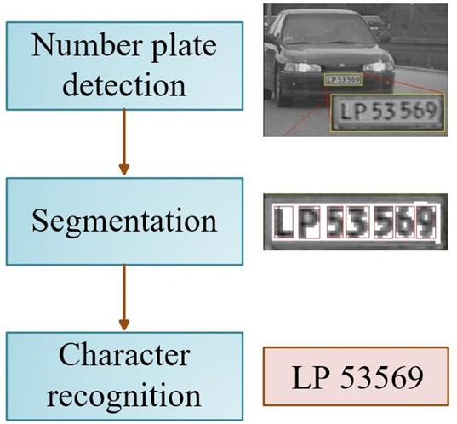

**Fig 3.1:- Steps involved in ANPR**

* 1. **Code**

**import cv2**

**harcascade = "model/haarcascade_russian_plate_number.xml" cap = cv2.VideoCapture(0)**

**cap.set(3, 640) # width cap.set(4, 480) #height**

**min_area = 500**

**count = 0**

**while True:**

**success, img = cap.read()**

**plate_cascade = cv2.CascadeClassifier(harcascade) img_gray = cv2.cvtColor(img, cv2.COLOR_BGR2GRAY)**

**plates = plate_cascade.detectMultiScale(img_gray, 1.1, 4) for (x,y,w,h) in**

**plates: area**

**= w * h**

**if area > min_area:**

**cv2.rectangle(img, (x,y), (x+w, y+h), (0,255,0), 2) cv2.putText(img, "Number Plate", (x,y-5),**

**cv2.FONT_HERSHEY_COMPLEX_SMALL, 1, (255, 0, 255), 2)**

**img_roi = img[y: y+h, x:x+w] cv2.imshow("ROI", img_roi)**

**cv2.imshow("Result", img)**

**if cv2.waitKey(1) & *0x*FF == ord('s'): cv2.imwrite("plates/scaned_img_" + *str*(count) + ".jpg", img_roi) cv2.rectangle(img, (0,200), (640,300), (0,255,0), cv2.FILLED)**

**cv2.putText(img, "Plate Saved", (150, 265), cv2.FONT_HERSHEY_COMPLEX_SMALL, 2,**

**(0, 0, 255), 2)**

**cv2.imshow("Results",img) cv2.waitKey(500) count += 1**

## CHAPTER 4 ANALYSIS

* 1. 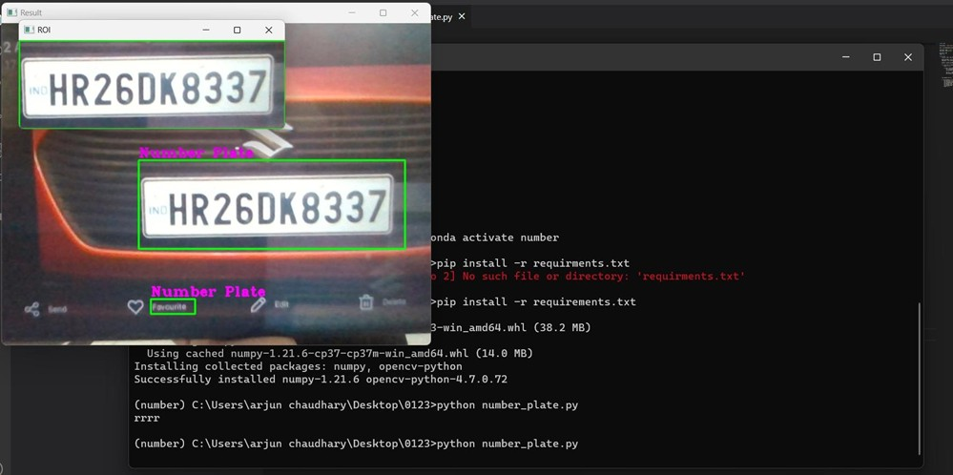**Results**

**Fig 4.1:- Getting Car Plate details**



**Fig 4.2:- Plate details saved for OCR**

* 1. **Uses**

Smart Parking Management Traffic Violation Detection Blacklisted Vehicle Detection

Integration with Boom Barrier for Automated Access Control

Most of the time the image quality and orientation is correct, the program was able to identify the Vehicle Number Plate and read the number from it.

**Chapter 5**

**Smart Plate vs Normal Number Plate**

Smart vehicle number plates, also known as digital number plates or intelligent number plates, have emerged as a technological advancement in the automotive industry. These innovative plates incorporate various features and capabilities that go beyond the traditional, static number plates commonly used on vehicles. This article aims to explore the differences between smart vehicle number plates and normal vehicle number plates, highlighting their benefits, functionality, and potential applications.

* + 1. **Appearance and Composition:**

Traditional Vehicle Number Plate:

A conventional vehicle number plate typically consists of a combination of letters and numbers arranged on a reflective material. The design and color scheme of these plates may vary across different regions and countries, but their primary purpose is to display a unique identification code for the vehicle.

Smart Vehicle Number Plate:

Smart vehicle number plates, on the other hand, feature a dynamic display, enabling the presentation of various types of information. They are composed of a digital screen, typically an LED or e-ink display, which replaces the static text found on traditional plates. This digital display allows for real-time updates and customization of the information displayed.

* + 1. **Features and Functionality:**

Traditional Vehicle Number Plate:

Normal vehicle number plates serve as identifiers for vehicles, displaying alphanumeric codes unique to each vehicle. They primarily serve a regulatory purpose, enabling law enforcement agencies and automated systems to identify and track vehicles.

Smart Vehicle Number Plate:

Smart vehicle number plates provide several additional features and functionalities, including:

* + - 1. Real-Time Information: With a digital display, smart number plates can

show real-time information such as vehicle speed, location, and registration status. This feature can be particularly useful for fleet management, law enforcement, and toll collection systems.

* + - 1. Customization and Personalization: The digital nature of smart number plates allows for customization and personalization options. Users can personalize their plates with custom messages, images, or even promotional content, provided it adheres to legal guidelines.
      2. Tracking and Security: Smart number plates can incorporate GPS tracking technology, enabling vehicle owners and authorized individuals to track their vehicles in case of theft or unauthorized use. This feature enhances security and facilitates recovery efforts.
      3. Electronic Payment Integration: Some smart number plates are equipped with contactless payment capabilities, allowing for seamless integration with toll collection systems or parking payment systems. This streamlines the payment process and reduces congestion.
      4. Emergency Services Integration: Smart number plates can be integrated with emergency services systems, enabling immediate identification of vehicles involved in accidents or emergencies. This integration expedites response times and enhances overall safety.
    1. **Potential Applications:**

Smart vehicle number plates have the potential to revolutionize various aspects of the automotive industry. Here are a few potential applications:

* + - 1. Traffic Management: Smart number plates can assist in traffic management systems, providing real-time data on vehicle flow, congestion, and routing. This information can be utilized to optimize traffic patterns and reduce gridlock.
      2. Law Enforcement: The dynamic nature of smart number plates aids law enforcement agencies in identifying stolen vehicles, tracking offenders, and monitoring traffic

violations. Automated systems can instantly recognize and flag non-compliant vehicles.

* + - 1. Vehicle Rental and Sharing: Smart number plates can be utilized in vehicle

rental and sharing services to streamline the booking and identification process. Digital plates can display information such as booking status, driver details, and payment verification.

* + - 1. Advertising and Marketing: Businesses can leverage smart number plates as an advertising medium. By displaying promotional content on digital plates, advertisers can reach a wider audience and increase brand visibility.

# Conclusion

Our work mainly proposes a plate localization and extraction technique from vehicle number plates. Firstly extraction of plate location, then separation of the plate characters individually by performing different pre-image processing techniques and segmentation, finally the segmented numbers are correlated with the standard templates in the library. In order to extract the plate location a bounding box method is used. And also each character is also segmented using the same bounding box method. The Segmented characters are identified by using the Template Matching Method. The suggested method is tested with various types of vehicles like four wheelers and with yellow and white background. The number plates with additional unnecessary data are also segmented with great accuracy.

**References**

Reference [6] Nima Asadi, ” A Study of Automatic Vehicle Number Plate Recognition Algorithms and Techniques”, Intelligent Embedded Systems [7] P. Mathivanan, B. Ganesamoorthy and P. Maran,” Watershed Algorithm Based Segmentation For Handwritten Text Identification”, ICTACT Journal on Image And Video Processing, Volume: 04, Issue: 03,pp 767772, February 2014 [8] Attila József Kun, Zoltán Vámossy,” Traffic Monitoring with Computer Vision”,IEEE, Applied Machine Intelligence and Informatics, 2009 [9] Ray Smith,” An Overview of the Tesseract OCR Engine”, Document Analysis and Recognition, ICDAR 2007. 9th International Conference, Pages: 629 – 633 [10] Chirag Patel, Atul Patel, Dharmendra Patel,” Optical Character Recognition by Open Source OCR Tool Tesseract: A Case Study”, International Journal of Computer Applications (0975 – 8887) Volume 55– No.10, October 2012 [1] A. Katartzis and

M. Petrou, "Current trends in super- resolution image reconstruction," Image Fusion: Algorithms and Applications, 2008. [2] Jameson, H. S. Abdullah, S. Norul, A. N. Ghazali, N. Nur, and N. A.Zamani, "Multiple Frames Combination Versus Single Frame Super Resolution Methods for CCTV Forensic Interpretation," Journal of Information Assurance & Security, vol. 8, 2013. [3]B. Zitova and 1. Fiusser, "Image registration methods: a survey," Image and Vision Computing, vol. 21, no. II, pp. 977- 1000, 2003. [4] S. C. Park, M. K. Park, and

M. G. Kang, "Super-resolution image reconstruction: a technical overview," Signal Processing Magazine, IEEE, vol. 20, pp. 21-36, 2003. [5] P. Vandewalle, S. SU, and M. Vetterli, "A frequency domain approach to registration of aliased images with application to super- resolution," EURASIP Journal on Advances in Signal Processing, vol. 2006,2006

# CONTRIBUTIONS

**Team Members** Arjun Chaudhary Anish Thumula Aishwarya Shukla

### Contributions:

**Arjun Chaudhary**

Worked on the coding stage of the project, involving Vehicle Number Plate Detection and Segmentation Process. Involved in making ppt and report.

### Anish Thumula

Worked on the coding stage of the project, involving Segmentation and Recognition Process. Involved in making ppt and report.

### Aishwarya Shukla

Worked on collecting sample data for the project and verifying the results. Involved in making ppt and report.